Illustration of the full system

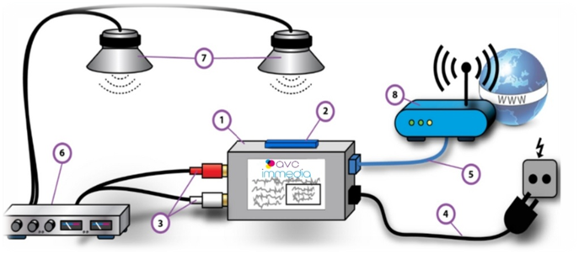

Kit supplied: AVC Immedia Player (1) SD Card (2) Audio Cables (3) Power Cable (4)

IT/ Connectivity & Audio – System Requirements

For a successful connection to Subway Live radio, the player requires:
- Ethernet cable (5)
- Amplifier (6)
- Speakers (7)
- Standard ethernet port (8)

Installing your music player

Step 1
Connect the AVC Immedia player (1) using the power cable supplied (4)

Step 2
Connect the player (1) to your amplifier using the audio cables (3). You should now hear the Subway Live Radio. If you have no sound, please check your amplifier is powered on and the cables secure. The amplifier controls the volume.
Any sound issues should first be escalated to your amplifier and speaker supplier.

Step 3
Connect the player (1) to an available port on your router (8) with the ethernet cable (5)

Testing
- A useful test is to take out the SD card (2) by pressing gently on the top of the SD card and removing it, if the music is playing you are hearing the Subway live radio (please place the SD card Back into the player and keep this in place times)
- The SD Card is for back-up purposes only and will supply music should your internet connection suffer an outage or buffering. The SD card is updated between the hours of 11:30pm and 06:00am and should be left switched on.
- If the player does not play music when the SD card is removed, this will be a connectivity issue (see below)

Connectivity

- We suggest that the player is connected directly into the router for the best quality of service. However, if no ports are available on the router, you may consider using a network switch.
- Any connectivity issues should first be escalated to your Internet Service Provider, remembering that the player requires >56 kbps available bandwidth.
- Refer to your internet provider if you need assistance with finding the appropriate port for the player. The player should be connecting to the IP address 185.96.67.77 or 185.96.67.77 and port 8100 & 8010, this information can be given to your internet provider.

Zen

If the store has internet supplied by Zen, please ensure that the corporate port 3 is used for Subway Radio. See image below.

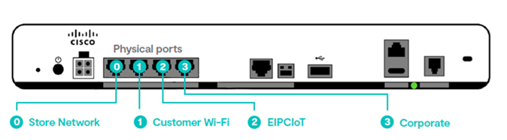

O2

If the store has internet supplied by 02, please do not use port 0 (port zero is used for the O2 WIFI only) Please use port 1,2 or 3. See image below.

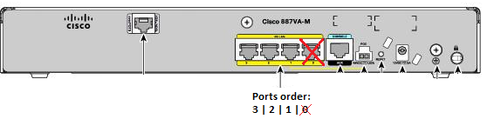

If you require assistance or have any general queries, please contact our Business Support team at AVC Immedia who are happy to help on +441635 556200 or alternatively email subwayire@avcimmedia.com

